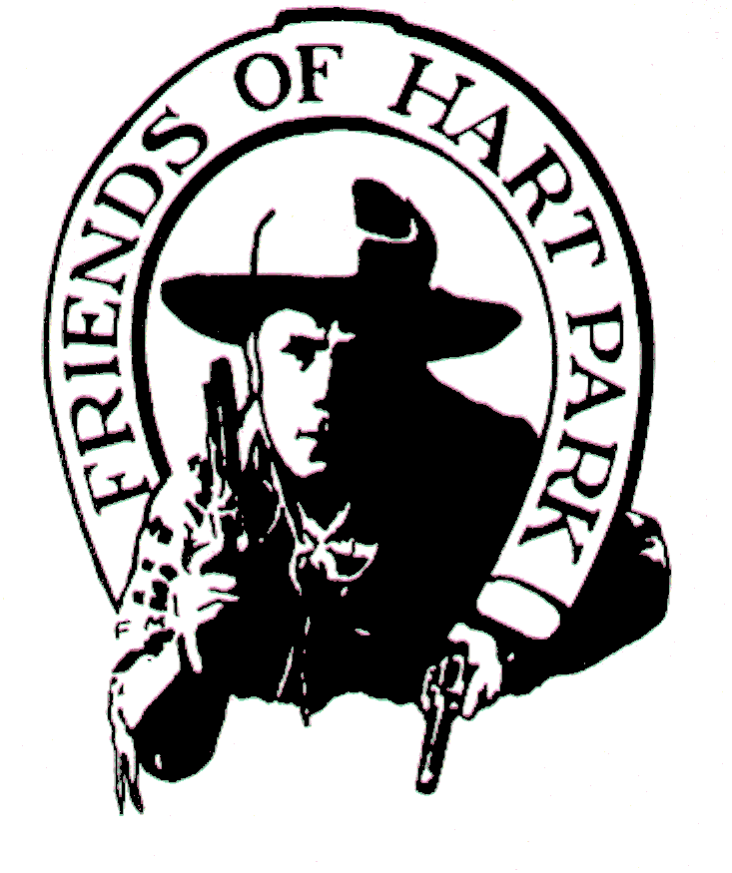

William S. Hart Park

Hart Holiday Boutique & Craft Fair

When: Saturday & Sunday, November 23rd & 24th, 2019 - 10:00a.m. to 4:00p.m.

Set-up: Fri. (11/22) Noon to 7p.m., Sat. 7a.m. to 10a.m. & 4p.m. to 7p.m.
Tear-down: Sat. at 4p.m. to 7p.m. and Sun at 4p.m. to 7p.m.

Where: William S. Hart Park, 24151 Newhall Ave, Newhall, CA 91321 – Hart Hall

Deadlines: (To pay by check, 16 November 2019) - After November 16th, 2019, CASH ONLY.

Space Fee: $70 for each 8 foot table $50 for each 6 foot table (Includes chairs)

THE SUNDAY RESERVATION IS HALF PRICE WITH A TWO DAY PAID RESERVATION.
To reserve a space(s), return this form with the NON-REFUNDABLE ENTRY FEE

Specifications: Vendors must furnish their own set-ups and display equipment. Displays and
goods may not block entrances and walkways. Vendors are responsible for all taxes and permits.
Booths must be attended at all times. Your space must be secured before leaving Saturday. Vendors can leave booth spaces in place overnight and are authorized to erect their setups up to 9 feet tall.

Holiday Boutique Entry Form

Return this form to: William S. Hart Park, 24151 Newhall Ave, Newhall CA 91321

Make check payable to: FRIENDS OF HART PARK.

NAME _______________________________ PHONE/EMAIL _______________________________
ADDRESS ________________________________City_________________ State____ Zip_______

One 8 foot table- Day one: $70 _____ Day two: $70 ____ Both days: $105 _____
Two 8 foot tables- Day one: $140 _____ Day two: $140 ____ Both days: $210 _____
One 6 foot table- Day one: $50 _____ Day two: $50 ____ Both days: $75 _____
Two 6 foot tables- Day one: $100 _____ Day two: $100 ____ Both days: $150 _____

Total Fees: $_________

Current FOHP members have an additional 10% fee discount

Permittee agrees to indemnify, defend and save harmless: the County of Los Angeles, its agents, officers and employ-
ees from and against any and all liability; or expense, including defense cost, and legal fees; and claims for damages
of any nature whatsoever, including, but not limited to, bodily injury, death, personal injury or property damage
arising from, or connected directly with, its services herein, on behalf of staff by any person pursuant to this agreement.

_______________________________________________ ________________________________________
Vendor Signature Date

Desirable but not exclusive; vendors should have a holiday presentation. For more information: Al Ewing, Event Coordinator at (661) 259-1750 or email: aewing@parks.lacounty.gov

